Product object
Id, pname, price etc
By default json server id unique consider. But if we use pid(it can duplicate).
http://localhost:3000/products all product details
Get : Get resources in json format like products
http://localhost:3000/products/100 search particular product details
Get with path param : search resource base upon unique property
Id
Post : store the product details

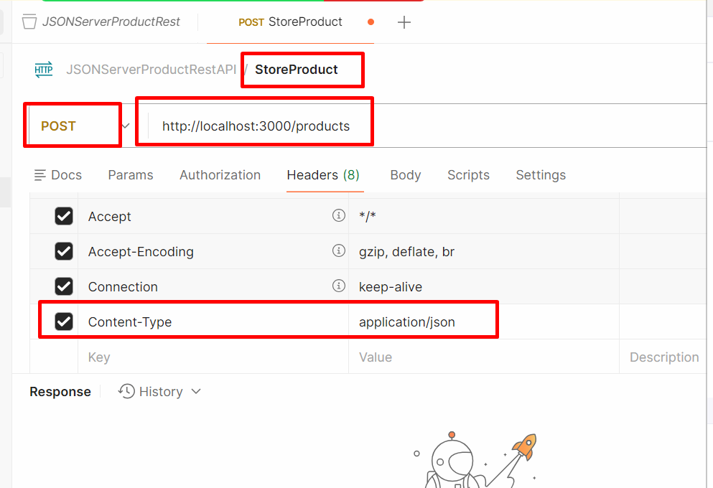

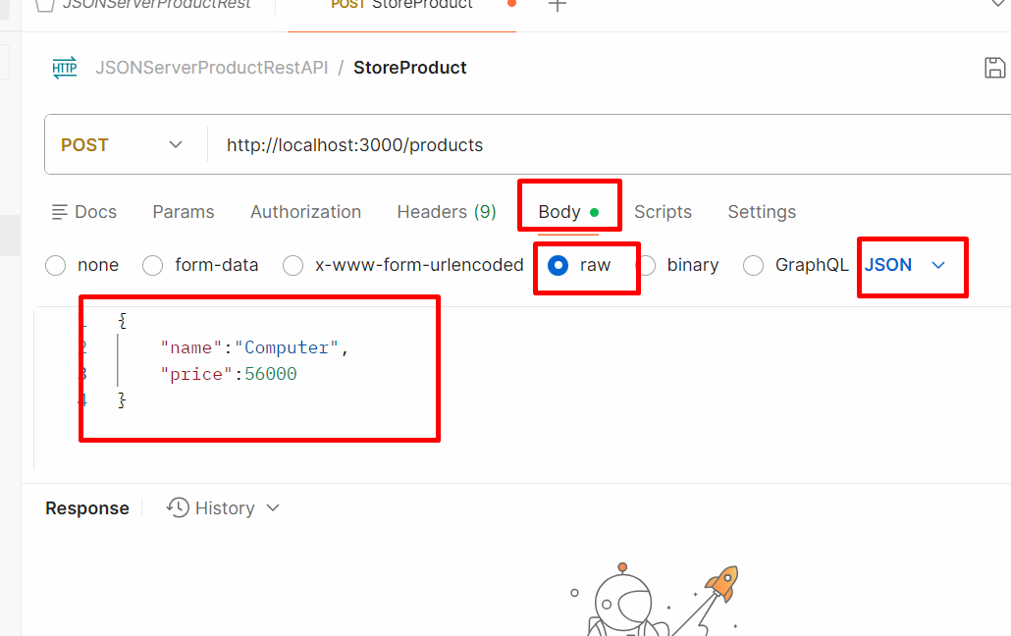

Put : update the product information using id property
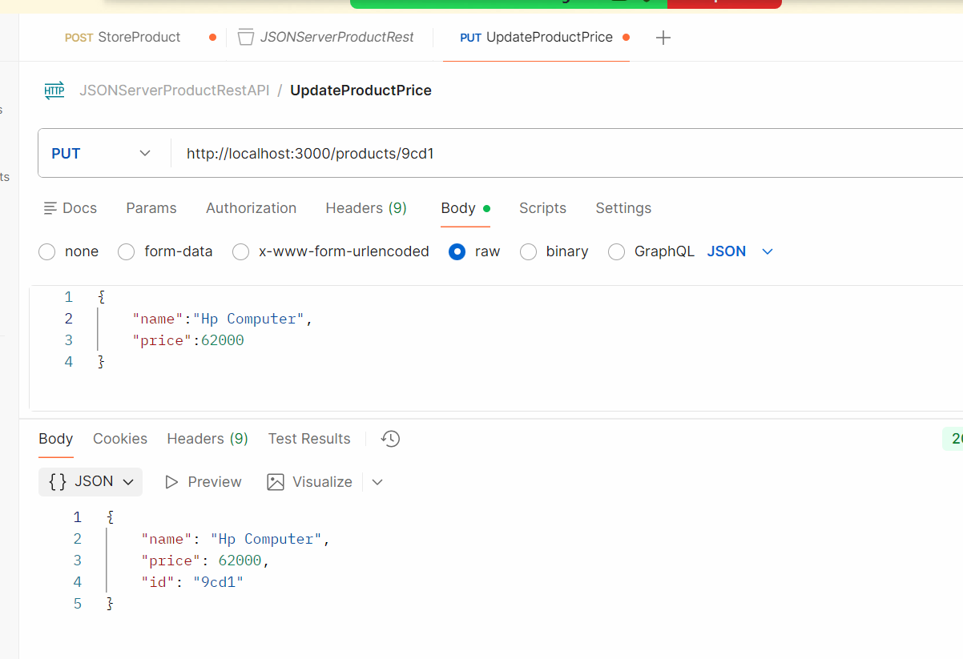

Delete : delete method is use to delete the product using id property

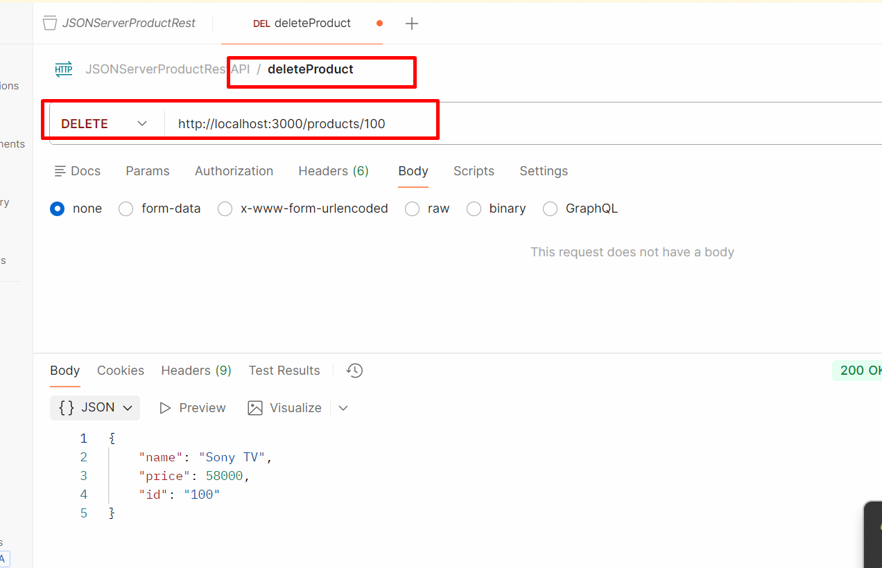

To test these http method we need rest api plugin ie postman or we can test using curl command also.

React JS
Html:
CSS:

JS : JavaScript :
Whenever we run any web page on browser internally it create DOM hierarchy
Html root tag or parent tag
Head body
Meta div
Title p textNode
Script
Style
DOM Operation
document.getElementById() getElementByName(), getElementByTagName()
using DOM parser we can read, write and update HTML content dynamically.

Library or framework
jQuery : jQuery is third party JS libraries which contains lot of pre defined function which internally connected with each other to read, write and update HTML content easily.
Load the DOM ie page
And select the particular tag base upon selector as name, id,class etc and do the some operation on that particular tags.
Angular Framework : if we develop any application using any framework by default we are following standard. Angular internally follow MVC (model view controller architecture). Controller is replaced by component.
If design patter. Best practice(solution for repeating problem).
React JS: React JS is light weighted library. In Reat JS we focus only on View rather than MC

Before Angular or React JS or Vue JS :
We were developing MPA
SPA : React JS , Angular Framework and Vue JS provide a features as SPA (Single Page Application).
MPA
Index.html application.html
Hyper link
Submit button
Using JS code
In SPA we are loading only part of the content rather than whole web page.

React JS : React JS is a third party open source SPA library provided by Facebook.
React JS use component base architecture concept.
Component is use to control the view or part of view in web page.
React JS support Virtual DOM.

Creating first react js project using vite framework

npm create vite@latest my-react-app
please select : React
please select : JavaScript
use rolldown-vite : no
Yes
It install few dependencies
Then project launch
Open browser and write the URL as
http://localhost:5173/

stop the project using Cntr + C or Cntr +D
move inside a project directory and open the project in VS code
to run the project once again
npm run dev (this command we need run side a project directory)
In React JS we use the concept as Component
Component is use to control the view or part of the view in web page.
In React We can create component using
- Function style : ES5 style
- Class style : ES6 style

In react every component return JSX (JavaScript XML or JavaScript extension). It return static or dynamic HTML code. Using JSX concept react component allow to write html code inside a functions.
Using components in react we can create user defined tags. That component can created using function style or class style.

